Importance of Visualizations in Research Projects

Data exploration begins with data, which is the foundation of data science. Data scientists utilize exploratory data analysis (EDA), which frequently uses data visualization techniques, to examine and analyze data sets and highlight their key features.

EDA offers a better knowledge of the variables in the data collection and their interactions and is mostly used to investigate what data might reveal beyond the formal modeling or hypothesis testing assignment. It can also assist you in assessing the suitability of the statistical methods you are thinking about using for data analysis. EDA techniques were first created by American mathematician John Tukey in the 1970s, and they are still a popular approach in the data discovery process today.

There are four primary types of EDA:
- Univariate non-graphical.
- Univariate graphical.
- Multivariate non-graphical
- Multivariate graphical
Other common types of multivariate graphics include:
- Scatter plot
- Multivariate chart
- Run chart
- Bubble chart
- Heat map
The two main programming languages for the EDA are Python and R. Kaggle is the biggest data-science related coding platform where a lot of people contribute to a dataset by their expertise in EDA.

Important facets of EDA consist of:
- Analyzing the range, central tendencies (mean, median), and dispersion (variance, standard deviation) of data points is known as data distribution.
- Graphical Representations: Visualizing relationships within the data and variable distributions through the use of charts like histograms, box plots, scatter plots, and bar charts.
- Finding odd numbers that diverge from other data points is known as outlier detection. Outliers may be a sign of unique cases or data input errors, and they can have an impact on statistical analysis.
- Examining the connections between variables to determine how they could influence one another is known as correlation analysis. This involves generating correlation matrices and calculating correlation coefficients.
- Dealing with Missing Values: Identifying and determining how to handle missing data points, either by removal or imputation, based on their significance and the quantity of missing data.

The most important python libraries for EDA are:
Pandas, matplotlib, seaborn, plotly, etc.
And for R language: ggplot2, dplyr, tidyr, etc.

Examples of EDA plots:

- Here is a simple Histogram plot of Age of a group of students.

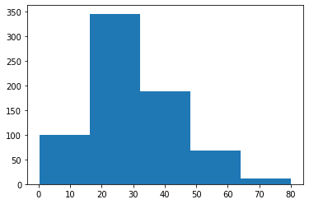

- Here is a scatter plot of total tip given by different sex depending on the total bill amount.

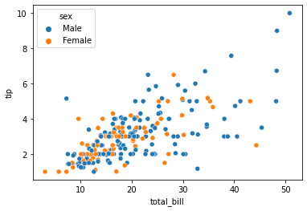

APPENDIX

References:

- https://www.geeksforgeeks.org/what-is-exploratory-data-analysis/
- https://www.ibm.com/topics/exploratory-data-analysis#:~:text=The%20main%20purpose%20of%20EDA,interesting%20relations%20among%20the%20variables.
- https://analyticsvidhya.com/blog/2021/06/exploratory-data-analysis-using-data-visualization-techniques/

Code to generate the plots:
1.
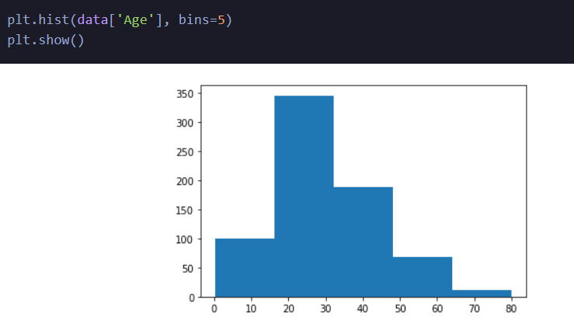
2.
